PERSONALISED NUTRITION PLAN QUESTIONAIRE
Please be as detailed as possible and expand questionnaire where appropriate.
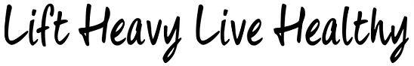

Name:

Email (To send the plan too):

Height:

Weight:

Age:

How many meals would you like to consume daily (3-6)?

How many calories do you roughly consume per day?

What are your goals? What are you trying to achieve?

What are your current eating and exercise habits? Are you a junk food person? Do you train? Etc.

What are your food likes or dislikes (include allergies). Please list as many things as possible here in order for us to make the plan tailored to you!

Have you got any injuries or health related problems that may affect nutrition e.g. diabetes, vegetarian etc? If so please be detailed and specific!

